Agreement

between

The Ewing Township Board of Education

and

The Ewing Township Administrators Association

For the Period

July 1, 2011 through June 30, 2014

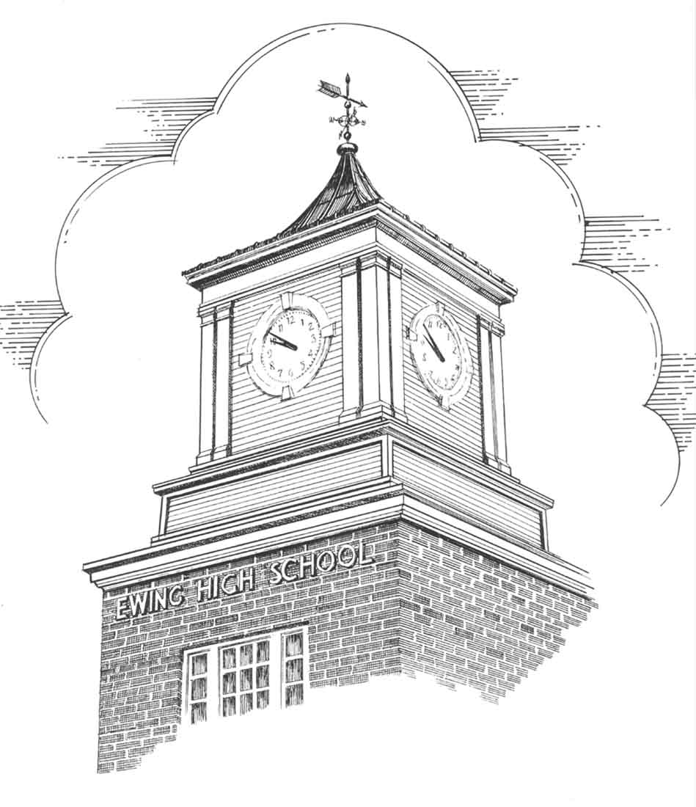

TABLE OF CONTENTS

ARTICLE PAGE

I. Recognition 1

II. Negotiation Procedure 1

III. Grievance Procedure 1

IV. Professional Rights 2

V. Insurance Protection 3

VI. Sick Leave 4

VII. Salary and Compensation 5

VIII. Professional Growth and Development 5

IX. Leaves of Absence 6

X. Term and Duration 8

Appendix A:

2011 – 2014 Salary Guides 9

I. Recognition

The Board of Education hereby recognizes the Administrative Staff for the purpose of collective negotiations concerning terms and conditions of employment under this Agreement with the Board for the following classifications:

Principals
Assistant Principals
Director of Special Services
Director of Athletics

but excluding:

all other supervisory, executive personnel and any other category of employees.

II. Negotiation Procedure

The parties agree to enter into collective negotiations over a successor Agreement. Such negotiations shall begin by mutual agreement no later than February 15 of the calendar year preceding the calendar year in which this Agreement expires. Any agreement so negotiated shall apply to all classifications recognized under this Agreement.

This Agreement shall not be modified in whole or in part by the parties except by an instrument in writing duly executed by both parties.

III. Grievance Procedure

Any grievance or dispute which may arise between the parties concerning the application, meaning or interpretation of this Agreement, shall be settled in the following manner:

Step 1 - Assistant Principals, with or without a representative, shall take up the grievance or dispute with their school principal within ten (10) working days of its occurrence. The Assistant Superintendent, immediate supervisor or school principal shall then attempt to adjust the matter and shall respond to the employee (or his/her representative) within three (3) working days.

Step 2 - If the grievance has not been settled, it shall be presented in writing by the employee (or his/her representative) to the Superintendent of Schools within five (5) working days after the Assistant Superintendent, immediate supervisor or School Principal's response is due. School Principals and the Directors covered hereby shall present their grievances to the Superintendent of Schools within ten (10) days of its occurrence. The Superintendent shall respond to the grievant (or his/her representative) in writing within five (5) working days.

Step 3 - If the grievance still remains unadjusted, it shall be presented by the employee (or employee's representative) to the Board of Education in writing within five (5) days after the response to the Superintendent of Schools is due. The Board of Education shall respond in writing to the employee (or the employee's representative) within one (1) month and ten (10) days. The decision of the Board of Education shall be final and binding.

Failure at any step to communicate the decision on a grievance within the specified time limitations shall constitute acceptance of a grievance as sustained. Failure to appeal within the specified time limitations from an answer which is unsatisfactory shall be deemed to constitute an acceptance of such response as dispositive.

IV. Professional Rights

No negative records shall be placed in an administrator's file, without first being discussed with the administrator. The administrator shall sign the document indicating that he/she has read the item of record. The administrator shall also have the right to submit a written answer to the material within ten (10) working days and his/her answer should be reviewed by the Superintendent or his/her designee and attached to the file copy.

V. Insurance Protection

A. The Board shall provide to all contracted administrators regularly employed a minimum of thirty (30) hours per week by the Ewing Township School District health care insurance protection consisting of the New Jersey State Health Benefits Program covering the administrator and his/her family dependents where appropriate. Employees shall contribute toward the cost of health care benefits coverage provided in accordance with the provisions of Chapter 78, P.L. 2011.

B. In addition the Board shall provide to all contracted administrators regularly employed a minimum of thirty (30) hours per week by the Ewing Township School District a prescription drug plan for the employee and his/her family with a company selected by the Board as follows:

Effective July 1, 2006:
twenty dollar ($20.00) co-pay for name brands, ten dollars ($10.00) co-pay for generic drugs, and no dollars ($0) co-pay for mail-in prescriptions
C. The Board shall provide to all contracted administrators regularly employed a minimum of thirty (30) hours per week by the Ewing Township School District the 1B Dental Plan, N.J. Dental Service Plan, Inc. (Delta Dental Plan) covering the administrator and his/her family dependents where appropriate. Said plan shall also include, subject to approval by the carrier, Ortho II Family Plan, orthodontic benefits for both adults and children (children covered to age 19, student-child to age 23).

D. Employees who retire may buy into the Prescription and Dental Plans at the group rate with the employee paying the premium costs in advance on the same payment schedule as the Board. The above is subject to the approval of the insurance carriers.

All insurance benefits shall be provided by the Board at the prevailing rate.

In no case will a person receive double coverage under any

available insurance plan.

E. Administrators who elect not to take either prescription and/or dental insurance shall receive one-half (1/2) of the value of the actual premium at his/her appropriate level of coverage. All requests for changes in coverage must be submitted in writing to the Superintendent or designee a minimum of sixty (60) days prior to July 1 or January 1, the dates on which any changes shall become effective.

Payment shall be made within forty-five (45) days following the conclusion of each six (6) month coverage period - i.e. July 1 through December 31 and January 1 through June 30.

All employee contributions to medical shall be paid by payroll deduction and/or Section 125 medical spending account disbursement, which shall be authorized by each employee.

VI. Sick Leave

A. Twelve (12)-month administrators shall receive 12 sick days annually.

B. Reimbursement for unused sick leave - Administrators who
retire after completing fifteen (15) years in Ewing Township shall receive payment for all unused accumulated sick leave in accordance with the schedule set forth below:

2011-2014 $115 per day up to a maximum of $14,720

In the event of death, payment for unused sick leave shall be paid to the estate of the administrator at the specified rate provided said administrator meets the conditions of Article VI, Paragraph B – i.e., 15 years.

C. An administrator planning to retire shall provide written notification to the Board of his/her intent to retire no later than December 1 immediately preceding the effective date of retirement, except in the case of an emergency or serious unforeseen event. Failure to comply with this procedure will result in a delay of payment until such time that (1) the Board allocates the money in its next annual budget and (2) said budget becomes effective.

VII. Salary and Compensation

A. The pay schedule for all employees covered by this Agreement shall be as set forth in Appendix "A" attached hereto.

B. A new administrator must be employed prior to January 1 in order to qualify for the next highest pay level on the salary guide for the following year.

C. Salaries shall be retroactive to July 1, 2011. This agreement and the appropriate retroactive payments shall cover all persons employed on that date whether deceased, retired, or no longer working in the district.

- Mileage Reimbursement

Employees shall be reimbursed in accordance with the requirements of N.J.S.A. 18A:11-12 and the regulations promulgated thereunder for work-related travel on voucher submitted.

- The Board shall pay the annual cost of active professional membership in the Principals and Supervisors Association. (state and national)

VIII. Professional Growth and Development

A. Administrators electing to take courses in State approved institutions or Board approved organizations may receive financial assistance from the Board of Education. Assistance is limited to the below listed amount:

2011-2014: $1140 per person - $4,560 unit maximum
Prior approval is required by the Board of Education and its decision is not subject to the grievance procedure.

- The total maximum payable under this provision per year
(July 1 - June 30) shall be in accordance with the above listed schedule; there shall be no carry over of unexpended monies.

IX. LEAVES OF ABSENCE

A. Holidays

1. Administrators shall follow the teachers' calendar plus Independence Day except as follows:

a. administrators shall be available during winter recess; and

b. administrators shall report for work in the district during all days of spring recess with the exception of Good Friday when said day is a designated holiday for teachers.

B. Vacations

1. All twelve (12) month Administrators shall receive twenty-two (22) vacation days annually. Upon the recommendation of the administrator's immediate supervisor and approval of the Superintendent, a maximum of five (5) vacation days may be carried over to the next school year. Under such circumstances, the total maximum number of earned vacation days shall not exceed twenty-seven (27).

- All vacation time must be recommended by the administrator's immediate supervisor and approved in advance by the Superintendent.

- Vacation days shall not be taken the first or last day of school or on days when inservice or training programs are provided by the district.
4. In the event an administrator is unable to utilize his/her vacation entitlement due to a serious bona fide medical condition and/or is unable to comply with the carryover provision of the Agreement due to a Board of Education directive or Board approved administrative directive, the ability to carry over additional days will be addressed on a case by case basis.
C. Personal Leave

1. Personal leave shall cover brief absences not chargeable to sick leave, or professional or semiprofessional assignments directly beneficial to the school system. It provides for up to three (3) days' leave at full pay during any one year for any of the following reasons:

a. Illness in the immediate family. Immediate family shall be considered: father, mother, brother, sister, spouse, child or any member of the immediate household.

b. Death of a relative or close friend.

c. Recognition of religious holidays.

d. Marriage of the professional or marriage in the family. Family shall be considered: father, mother, brother, sister, child, nephew, niece, brother-in-law, sister-in-law, father-in-law, and mother-in-law.

e. Court Subpoena.

f. Personal, legal business, or family matters which cannot be handled outside of school hours.
g. Any other emergency or urgent reason not included in (a) to (f) above, if approved by the Superintendent of Schools.

2. All requests for personal leave shall be submitted in writing, on the proper form, (in advance, except in the case of an emergency) recommended by the administrator's immediate supervisor and approved by the Superintendent or his/her designee; however, no more that two (2) requests will be approved for any one date.

Requests for personal leave on the day preceding or immediately following a vacation period, on the day preceding or immediately following a vacation period, on inservice days, or on dates of parent conferences will be honored only in unusual cases.

3. Up to five (5) additional days' leave, at the discretion of the employee, shall be granted for Death in the Immediate Family (immediate family is considered the same as subsection C.1a hereinabove); up to three (3) additional days' leave, at the discretion of the employee, shall be granted for death of a mother-in-law, father-in-law, or grandparent. Said bereavement days are separate and distinct and shall not be charged as either sick leave or personal leave set forth herein.

- Each administrator with unused personal leave days under Section C.1 as of June 30th of each school year shall have all such unused days added to his/her accumulated sick leave. Indication will be given annually of any conversion made to the sick leave account.

D. Family Illness Day

1. Each member of the ETAA shall be allowed one (1) family illness day with full pay per school year for use due to illness in the immediate family as defined herein above under subsection C:1. An unused family illness day shall not be accumulated from year to year.

X. Term and Duration

This Agreement shall be in effect as of July 1, 2011 and shall continue through June 30, 2014.

Ratified this 19th day of December, 2011.

Ewing Township Ewing Township Board of Education
Administrators Association

___________________________ ____________________________
Rodney J. Logan, President Karen McKeon, President

____________________________ _____________________________
Nicole Harris, Secretary Brian Falkowski, SBA
Administrator/Board Secretary

_____________________________ ____________________________
DATE DATE

APPENDIX A

2011-2012 | 1 | 2 | 3 | 4 | 5 | 6 | 7 | 8
Step | HSP | FMSP | EP | D.SS | DIS | EHSAP | FMSAP | EAP 12
1 | $138,642 | $133,032 | $129,564 | $128,238 | $121,710 | $122,016 | $117,120 | $113,856
2 | $139,842 | $134,232 | $130,764 | $129,438 | $122,910 | $123,216 | $118,320 | $115,056
3 | $141,576 | $135,762 | $132,396 | $130,458 | $125,970 | $124,134 | $119,340 | $116,076
4 | $143,310 | $137,292 | $134,028 | $131,478 | $128,010 | $124,950 | $120,360 | $117,147
5 | $145,044 | $138,822 | $135,660 | $132,498 | $130,050 | $125,817 | $121,890 | $119,238
6 | $146,778 | $140,352 | $137,292 | $133,824 | $132,090 | $127,704 | $123,930 | $121,380
7 | $148,512 | $141,984 | $138,924 | $135,864 | $134,130 | $130,866 | $125,970 | $123,981
8 | $150,246 | $144,024 | $140,658 | $138,210 | $136,170 | $133,620 | $128,010 | $126,480
9 | $152,541 | $146,268 | $143,004 | $141,576 | $138,210 | $136,680 | $130,151 | $129,336
10 | $156,060 | $149,838 | $148,563 | $145,044 | $140,811 | $139,536 | $134,130 | $132,396
2012-2013 | 1 | 2 | 3 | 4 | 5 | 6 | 7 | 8
Step | HSP | FMSP | EP | D.SS | DIS | EHSAP | FMSAP | EAP 12
1 | $140,215 | $134,493 | $130,955 | $129,603 | $122,944 | $123,256 | $118,262 | $114,933
2 | $141,415 | $135,693 | $132,155 | $130,803 | $124,144 | $124,456 | $119,462 | $116,133
3 | $142,639 | $136,917 | $133,379 | $132,027 | $125,368 | $125,680 | $120,686 | $117,357
4 | $144,408 | $138,477 | $135,044 | $133,067 | $128,489 | $126,617 | $121,727 | $118,398
5 | $146,176 | $140,038 | $136,709 | $134,108 | $130,570 | $127,449 | $122,767 | $119,490
6 | $147,945 | $141,598 | $138,373 | $135,148 | $132,651 | $128,333 | $124,328 | $121,623
7 | $149,714 | $143,159 | $140,038 | $136,500 | $134,732 | $130,258 | $126,409 | $123,808
8 | $151,482 | $144,824 | $141,702 | $138,581 | $136,813 | $133,483 | $128,489 | $126,461
9 | $153,251 | $146,904 | $143,471 | $140,974 | $138,893 | $136,292 | $130,570 | $129,010
10 | $155,592 | $149,193 | $145,864 | $144,408 | $140,974 | $139,414 | $132,754 | $131,923
Off Guide 1 |  |  | $151,534 |  |  | $142,327 |  | $135,044
2013-2014 | 1 | 2 | 3 | 4 | 5 | 6 | 7 | 8
Step | HSP | FMSP | EP | D.SS | DIS | EHSAP | FMSAP | EAP 12
1 | $141,819 | $135,982 | $132,374 | $130,995 | $124,203 | $124,521 | $119,428 | $116,032
2 | $143,019 | $137,182 | $133,574 | $132,195 | $125,403 | $125,721 | $120,628 | $117,232
3 | $144,243 | $138,406 | $134,798 | $133,419 | $126,627 | $126,945 | $121,852 | $118,456
4 | $145,492 | $139,655 | $136,047 | $134,667 | $127,876 | $128,194 | $123,100 | $119,704
5 | $147,296 | $141,247 | $137,745 | $135,729 | $131,059 | $129,149 | $124,161 | $120,765
6 | $149,100 | $142,839 | $139,443 | $136,790 | $133,182 | $129,998 | $125,223 | $121,880
7 | $150,904 | $144,430 | $141,141 | $137,851 | $135,304 | $130,900 | $126,814 | $124,055
8 | $152,708 | $146,022 | $142,839 | $139,230 | $137,426 | $132,863 | $128,937 | $126,284
9 | $154,512 | $147,720 | $144,537 | $141,353 | $139,549 | $136,153 | $131,059 | $128,990
10 | $156,316 | $149,843 | $146,341 | $143,794 | $141,671 | $139,018 | $133,182 | $131,590
Off Guide 1 | $158,704
Off Guide 2 |  |  | $154,565 |  |  | $145,173 |  | $137,745

9

